Use dump analysis to debug

**Introduction**

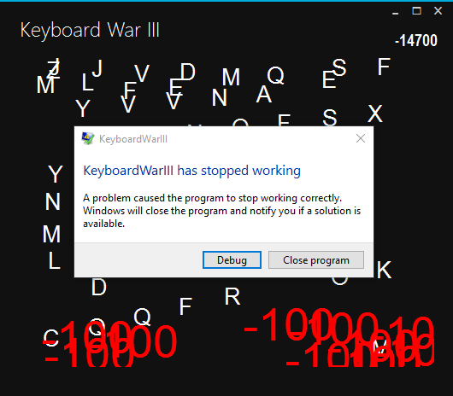Eric, as a programmer who wants to be an excellent keyboard master, made a game called "Keyboard War III". He shared the execution file of game (Keyboard War III) to his best friend, John, and invited him to be a keyboard master together. But John told him that the game crashed in his computer. Eric thought it was weird because the game ran very smoothly in his computer. Eric have been searching for the causes of problem for three days and tried to reproduce John’s bug on his own computer but he had difficulties in doing so . Could you teach Eric how to find the bug by the debugging techniques taught in Software Engineering practice class?

Figure 1. The crash of KeyboardWarIII

**Your Goals**

1. Run the KeyboardWarIII.exe until it crashed and crash as above. This should not be hard as expected. The KeyboardWarIII.exe is in the Application folder decompressed Application.zip downloaded from LMS.
2. Create a report document (WORD or PDF) by your student id. If your student id is “9487”, please create a “9487-KW-hw3.doc”. TA will announce how to submit your file for grading.
3. Find the call stack while the program crashed using the dump file of the crashed program.
   * After you successfully locate the call stack in Visual Studio, please take a screenshot and attach to report.doc
   * Please attach the screenshots of the call stack for every threads "UpdateThread"、"CreateMonsterThread", and "DetectThread". To your report
4. Explain and guess what goes wrong by judging from the information of call stack as much as you can

**Grading**: Your report will be graded by the following criteria

1. 60%, successfully produce the screenshots as described
2. 40%, explain the possible causes of the bug at your best by examining the information from your dump analysis. Then please describe what is your debugging hypothesis if you are responsible for debugging the bug.